Solutions

**I Comments and JavaDoc**

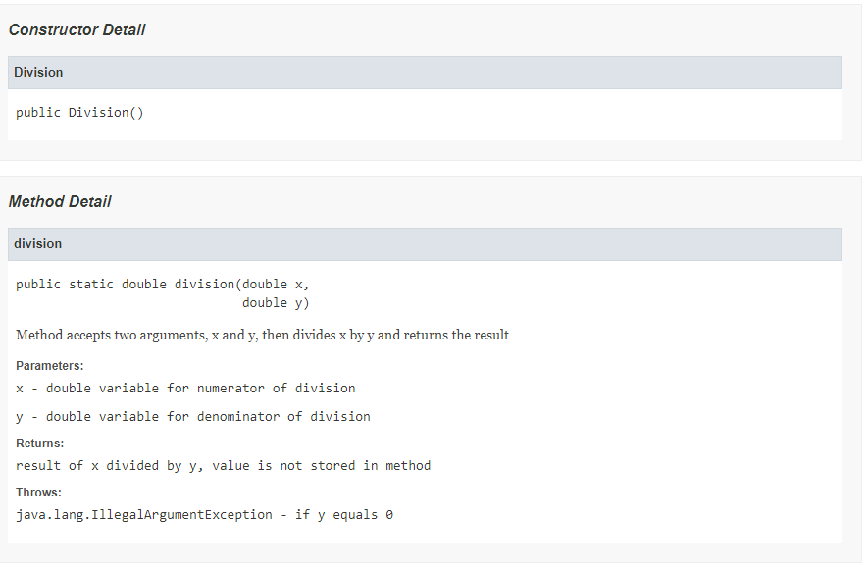

**II Refactoring: Extract Method, Pull Method, and Template Method**

public abstract class Party {

private String name;

//regular Methods

public void printName(){

System.out.println("Name: " + name);

}

//Template methods

protected abstract void printDetails();

}

public class Person extends Party {

private Date dob;

private String nation;

protected void printDetails(){

System.out.println ("Details: DOB-" + dob.toString() + ", Nation-" + nation);

}

}

public class Company extends Party {

private Date incorporated;

protected void printDetails(){

System.out.println ("Details: Incorporated-" + incorporated.toString());

}

}

**III Refactoring: Motivation and Techniques**

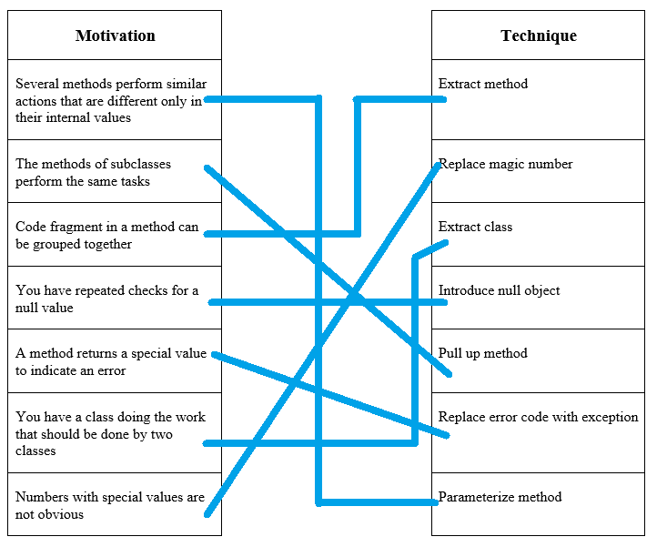

**IV Testing vs. Formal Verification**

Formal Verification

Pros

Considers all possible executions

Formally proves correctness

Cons

Difficult to prove correctness

Too expensive for most programs

Testing is more widely used that formal verification because it is more scalable and applicable to more programs.